Aadhaar Insights

A Secure Cloud-Based Analytics Framework

1. Introduction
India’s Aadhaar system forms the backbone of digital identity and plays a vital role in enabling access to government services, welfare schemes, and secure identity verification at scale. With millions of enrolments and demographic or biometric updates occurring regularly across states and districts, Aadhaar data presents a significant opportunity to understand societal trends, regional behaviour, and operational efficiency.
This project was developed as part of an online hackathon organised by UIDAI in collaboration with NIC and MeitY. The primary objective is to analyse anonymised Aadhaar enrolment and update datasets to extract meaningful insights while strictly adhering to data security, governance, and privacy principles.
Unlike conventional analytics projects, this solution adopts a real-world, government-grade architecture by integrating cloud storage, role-based access control, structured ETL pipelines, relational analytics, and interactive dashboards.

2. Problem Statement
Aadhaar enrolment and update data is generated continuously at a national scale. However, transforming this massive and sensitive dataset into actionable insights presents several challenges:
- Extremely high data volume with wide geographic diversity
- Requirement for extensive data cleaning and standardisation
- Sensitive nature of identity-related data demanding strict security controls
- Need for clear, decision-oriented insights for policy and operational stakeholders

Core Problem
To unlock societal and operational insights from anonymised Aadhaar data while ensuring security, integrity, scalability, and auditability throughout the data lifecycle.

3. Objectives of the Project
The key objectives of this project are:
- Secure storage and governance of anonymised Aadhaar datasets
- Cleaning and transforming raw data into analysis-ready formats
- Analysing enrolment and update trends across regions, age groups, and time
- Enforcing least-privilege access using IAM-based security
- Delivering insights through intuitive dashboards for informed decision-making

4. Overall Architecture Overview
The project follows a layered cloud architecture designed for clarity, scalability, and security:
- Storage Layer: AWS S3 (Raw and Cleaned Data Buckets)
- Security Layer: AWS IAM (Role-Based Access Control)
- Processing Layer: Python-based ETL Pipeline
- Analytics Layer: PostgreSQL Database
- Visualization Layer: Power BI Dashboards

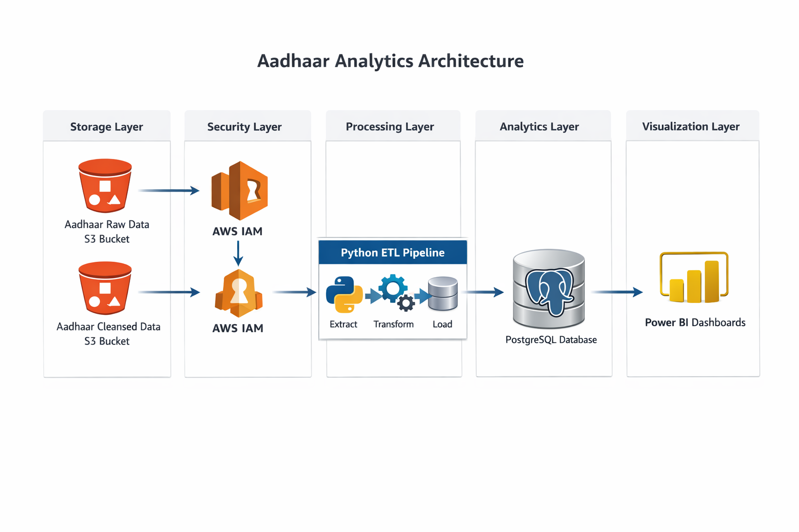

5. Datasets Used
The analysis is based on anonymised Aadhaar enrolment and update datasets provided by UIDAI. These datasets capture Aadhaar enrolment activity and subsequent updates across different age groups and geographic regions.

5.1 Aadhaar Enrolment Dataset
Purpose:
To analyse new Aadhaar registrations across various age groups and regions.
Key Columns Used:
- date – Date of enrolment activity
- state – State or Union Territory
- district – District of enrolment
- pincode – Pincode of enrolment location
- age_0_to_5 – Enrolments for age group 0–5
- age_5_to_17 – Enrolments for age group 5–17
- age_18_plus – Enrolments for age group 18 and above

5.2 Aadhaar Demographic Update Dataset
Purpose:
To analyse demographic updates made to existing Aadhaar records.
Key Columns Used:
- date – Date of demographic update
- state – State or Union Territory
- district – District of update
- pincode – Pincode of update location
- demo_age_5_to_17 – Demographic updates for age group 5–17
- demo_age_17_plus – Demographic updates for age group 18 and above

5.3 Aadhaar Biometric Update Dataset
Purpose:
To analyse biometric updates across different age groups and regions.
Key Columns Used:
- date – Date of biometric update
- state – State or Union Territory
- district – District of update
- pincode – Pincode of update location
- bio_age_5_to_17 – Biometric updates for age group 5–17
- bio_age_17_plus – Biometric updates for age group 18 and above

5.4 Data Scope and Usage
- All datasets are anonymised and contain no personally identifiable information (PII).
- Data was aggregated at monthly, state, and district levels to identify trends, update intensity, and regional hotspots.
- The datasets were used exclusively for analytical and visualisation purposes in compliance with hackathon guidelines.

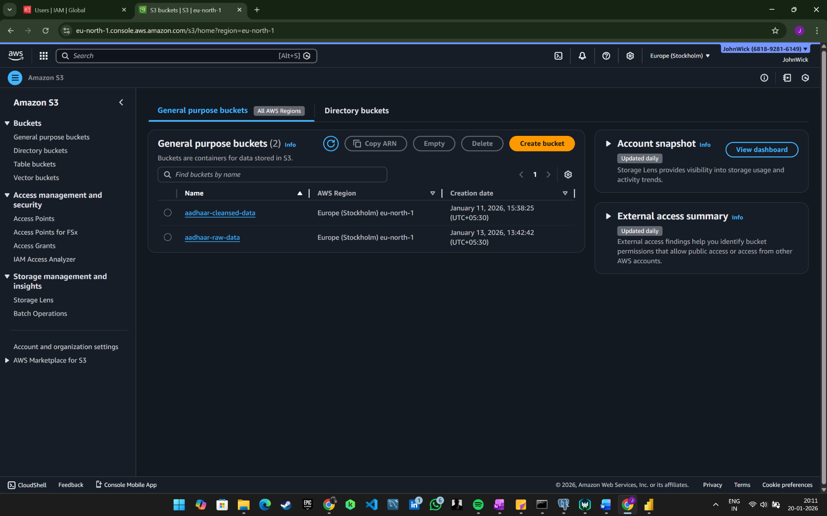

6. Security and Access Control (AWS IAM)
Security is a core design principle aligned with government and enterprise best practices.
- A dedicated IAM user with no direct permissions was created
- All operations are performed via IAM role assumption
- Access is granted using temporary credentials that automatically expire
- Least-privilege permissions are enforced
Permissions include:
- Read-only access to raw data bucket
- Write access to cleansed data bucket
- No delete permissions

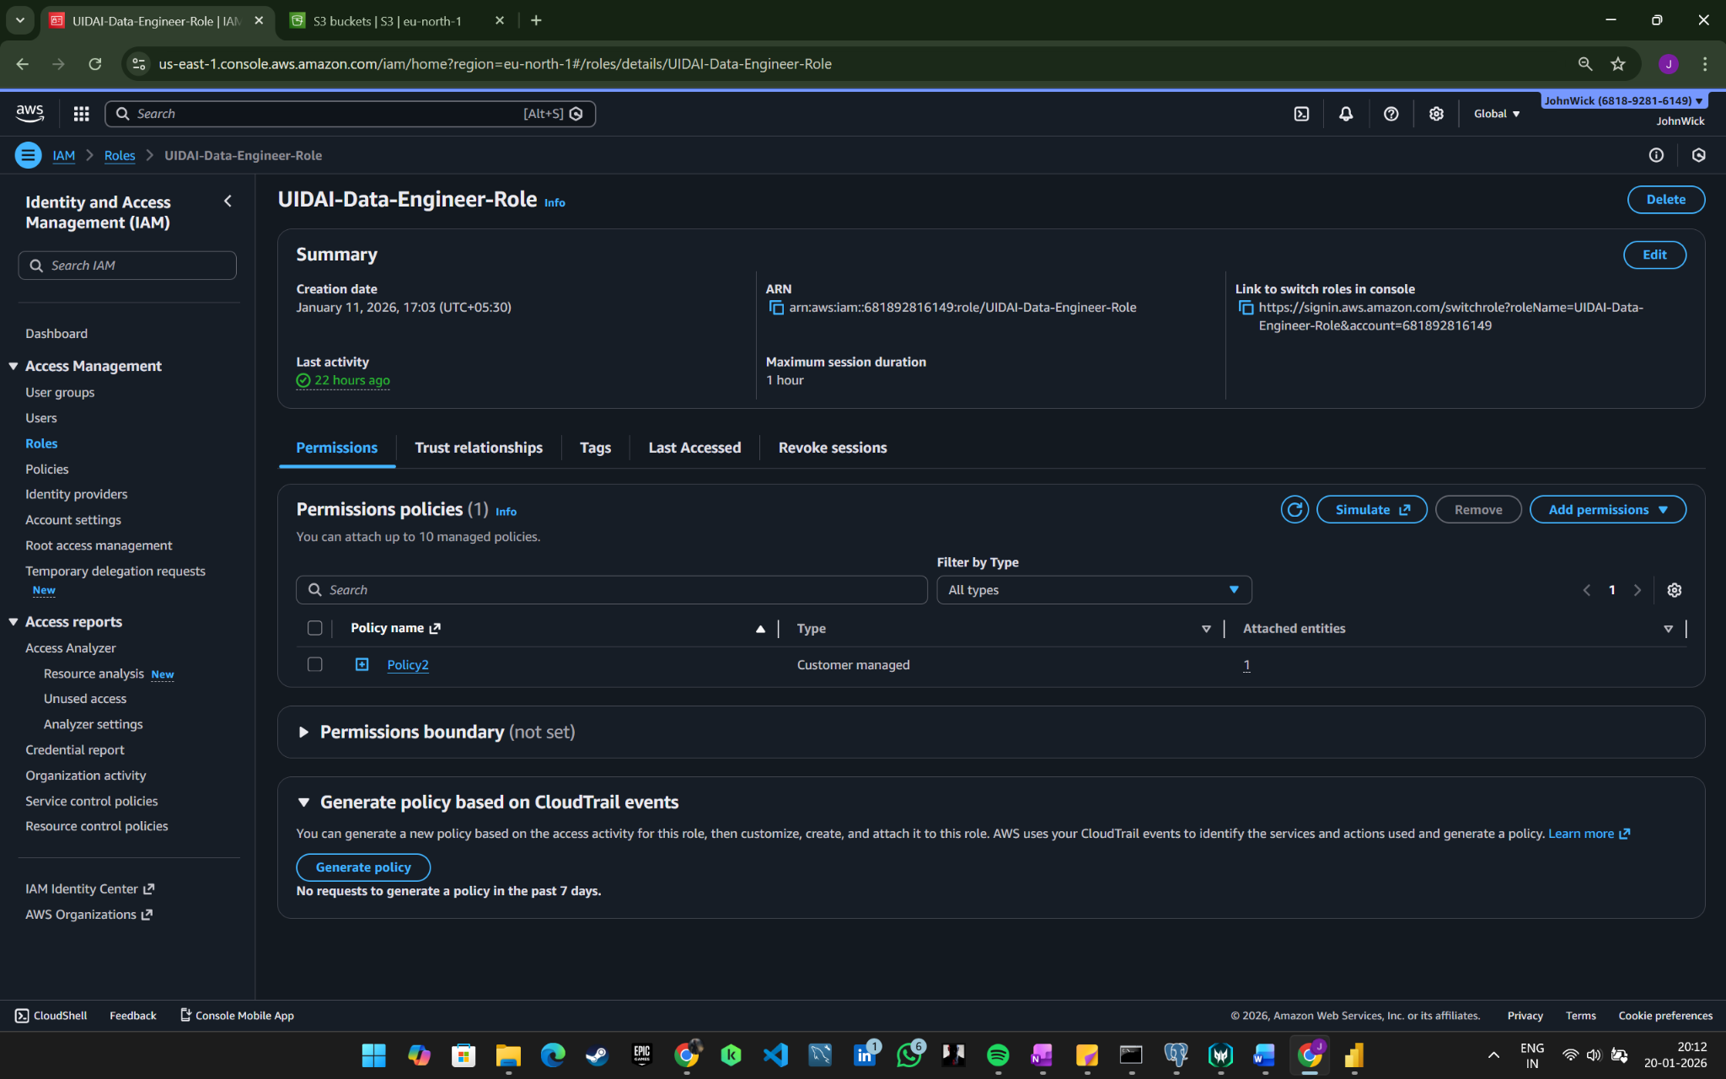
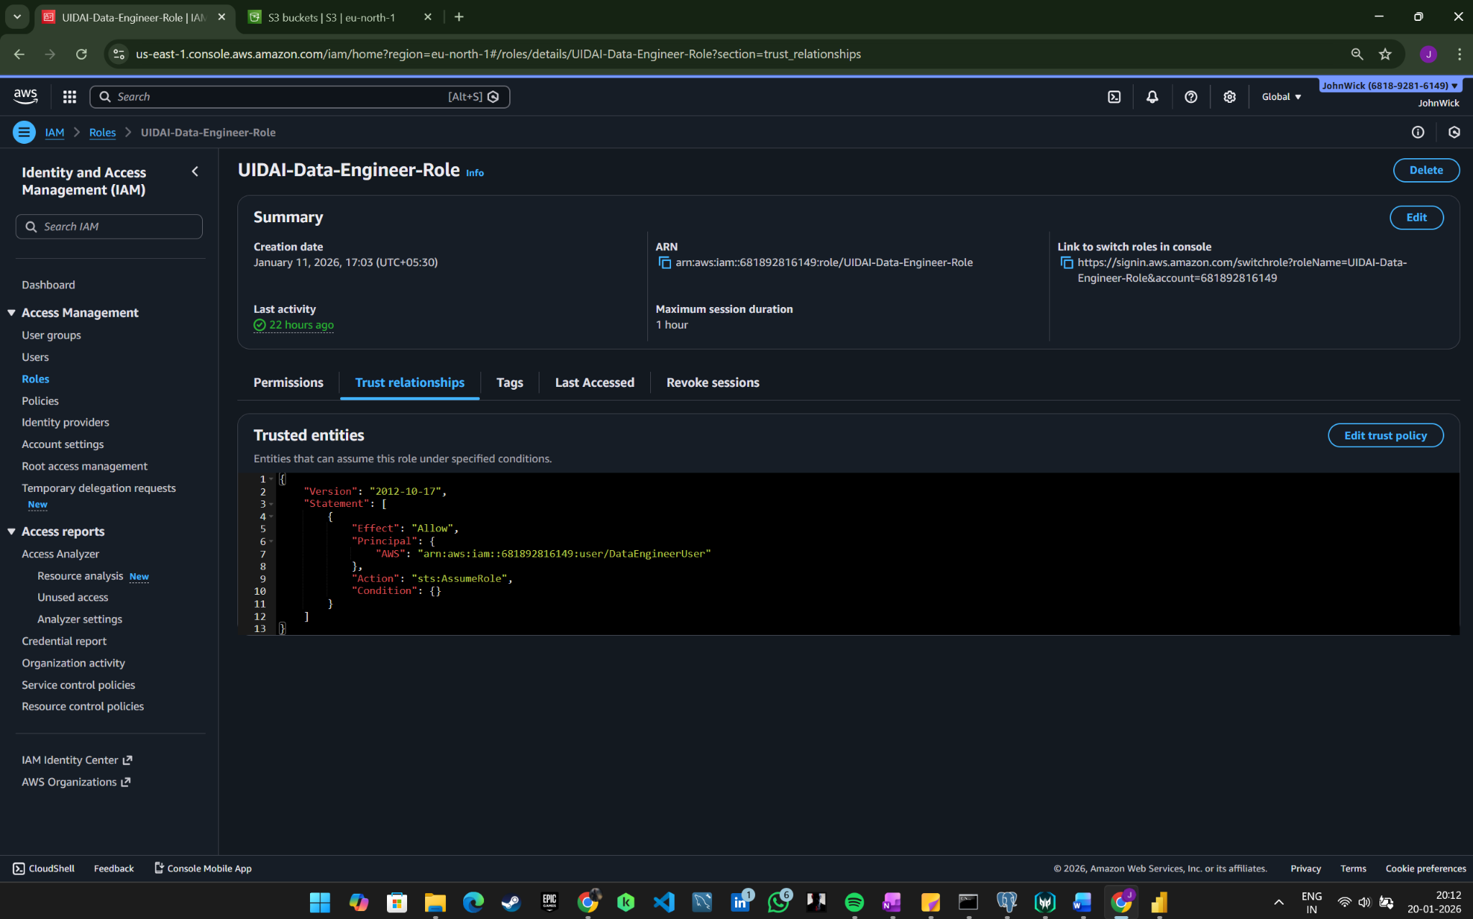

8. Data Processing Layer (Python ETL)
A modular Python-based ETL pipeline was implemented.

8.1 Extract
- Secure extraction of raw data from S3 using assumed IAM roles

8.2 Transform
Key transformations include:
- Handling missing and null values
- Standardising date formats
- Normalising state and district names
- Removing duplicate records
- Enforcing schema consistency

8.3 Load
- Cleaned data written back to the cleansed S3 bucket
- Ensures reliable downstream analytics

Assume Role & Secure S3 Access (Python)
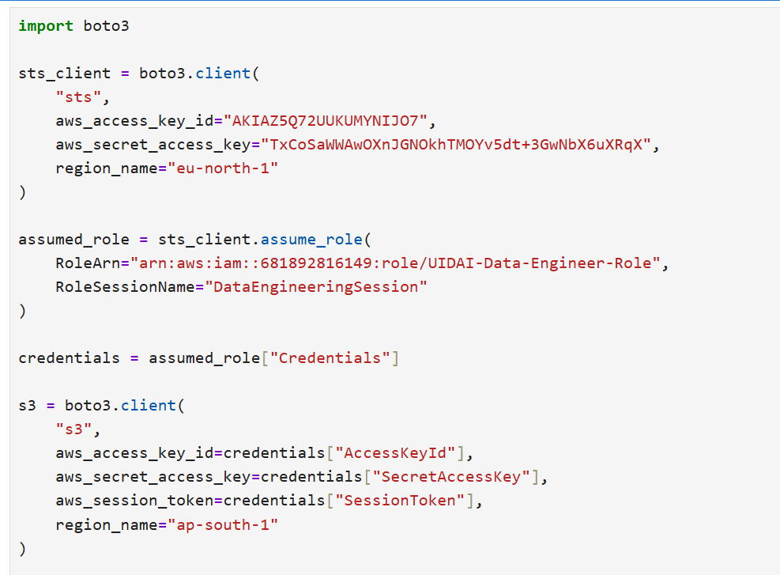

- Secure access to AWS S3 was implemented using IAM role assumption. Temporary credentials were generated via AWS STS, ensuring no permanent access keys were used and enforcing least-privilege access.

Data Cleaning and Transformation Logic
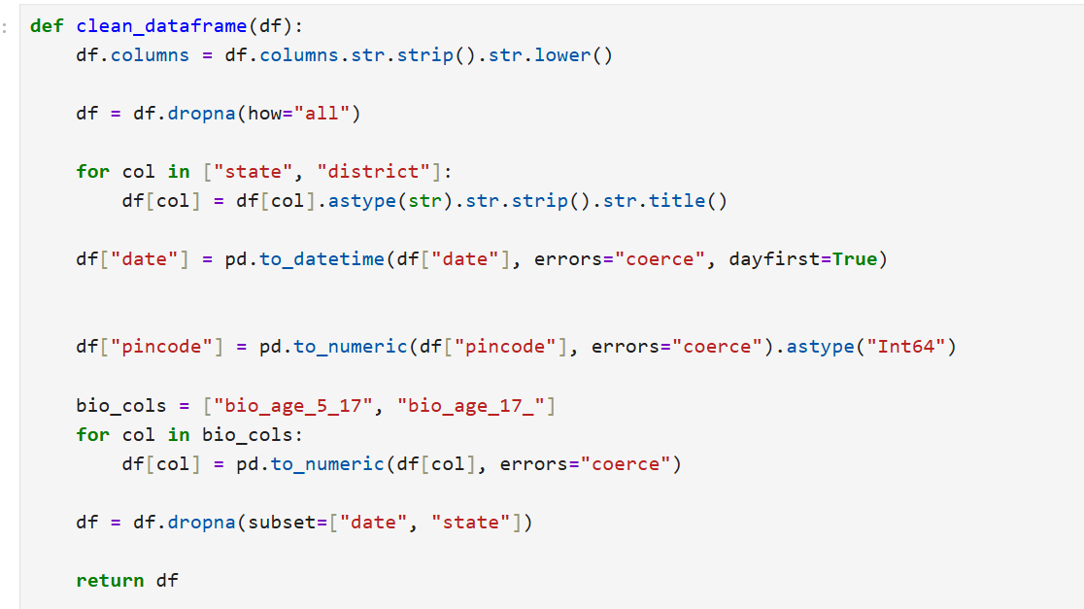

Writing Cleaned Data Back to S3

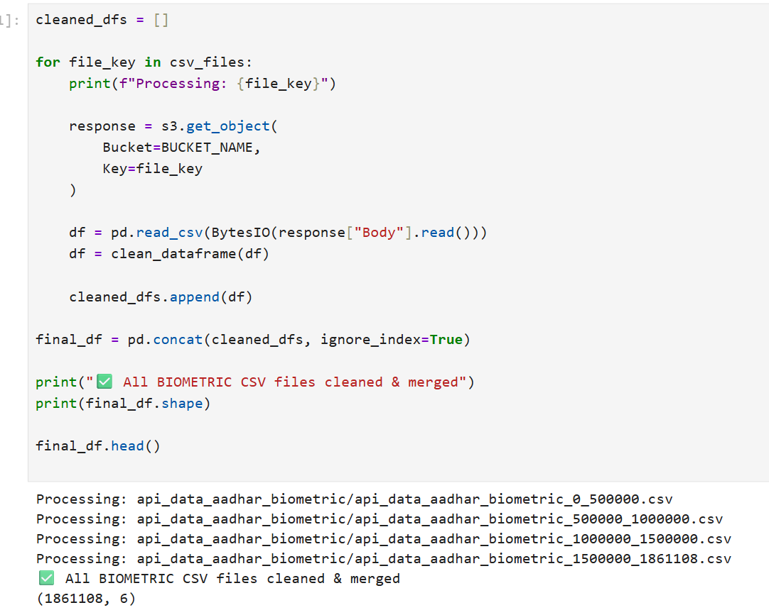

9. Analytics Layer (PostgreSQL)

9.1 Data Loading
- Cleaned datasets loaded from S3 into PostgreSQL tables
- Schema optimised for aggregation by state, district, age group, and time
- Database contains approximately 1.8 million records

9.2 SQL-Based Analysis
SQL queries were used to analyse:
- State-wise and region-wise trends
- Monthly update patterns
- High-frequency update regions
- Detection of anomalies and unusual spikes

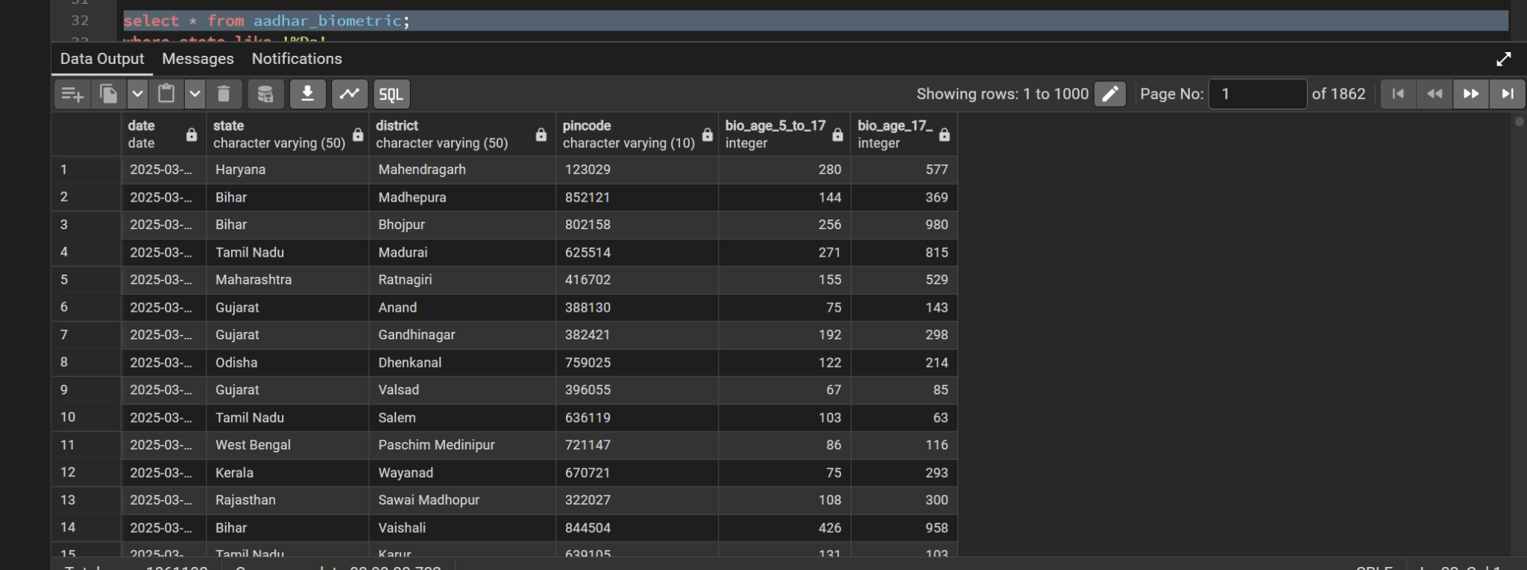

10. Visualization and Insights
Interactive dashboards were built using Power BI connected directly to PostgreSQL.

Key Metrics
- Total Updates: 119 million
- Biometric Updates: 70 million
- Demographic Updates: 49 million
- Updates per 1,000 adults
- Enrolments by age group
- State-wise and monthly trends
Dynamic filters enable analysis by state and time period, making insights accessible to non-technical stakeholders.

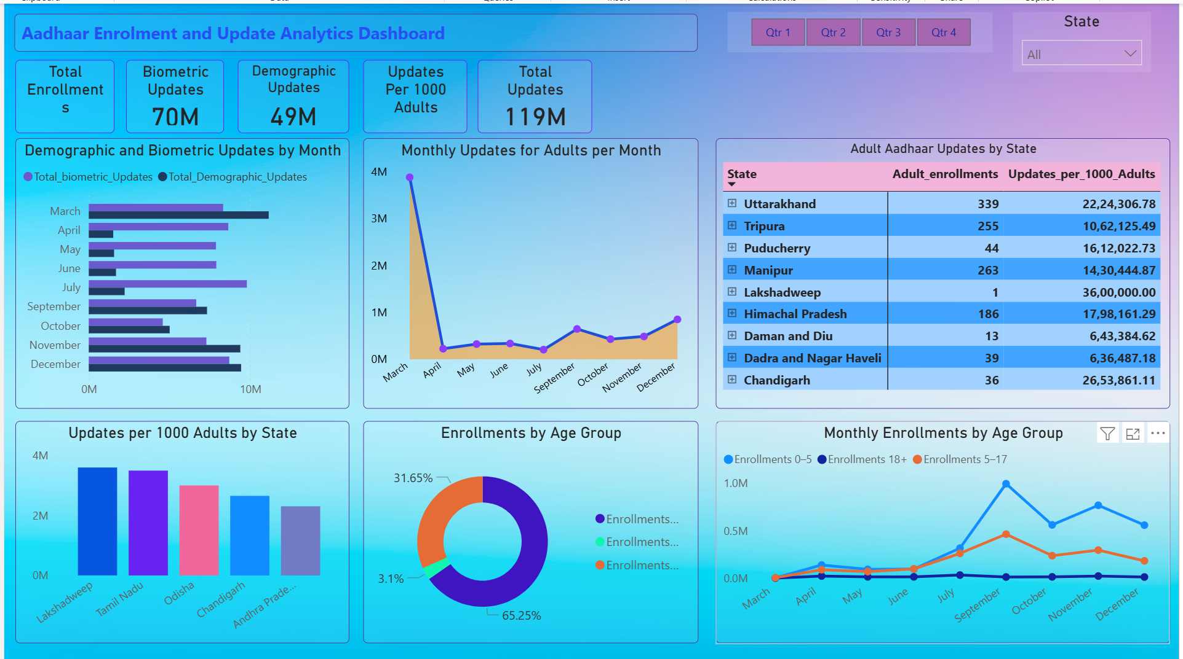

11. Key Insights and Use Cases
The solution enables:
- Identification of regions with low enrolment growth
- Detection of unusually high update frequencies
- Analysis of seasonal enrolment and update trends
- Inputs for infrastructure planning and outreach optimisation
These insights directly support policy formulation, operational efficiency, and resource allocation.

12. Limitations and Future Enhancements

Current Limitations
- Batch-based processing only
- No real-time streaming or predictive models

Future Enhancements
- Real-time pipelines using streaming frameworks
- Machine learning-based forecasting and anomaly detection
- Role-based dashboard access
- Scaling analytics using services such as AWS Glue or Redshift

13. Impact and Relevance
This project demonstrates how anonymised national-scale identity data can be responsibly analysed using modern cloud and analytics practices. The architecture serves as a reference framework for public-sector data systems, balancing insight generation with strict governance and security.

14. Conclusion
The project successfully delivers a secure, cloud-based analytics framework that transforms Aadhaar enrolment and update data into actionable insights. By integrating AWS S3, IAM-based security, Python ETL, PostgreSQL, and Power BI, the solution achieves both analytical depth and enterprise-grade governance.
This hackathon project reflects a practical, real-world approach to data-driven decision support in large-scale public sector systems.

